**VALUER REPORT UID NO.:CEV/RVO/299/2677/17112023 17.11.2023**

**To**

**The Asst. General Manager**

**UCO Bank, Sector-8, Panchkula**

**VALUATION REPORT ( IN RESPECT OF LAND / SITE AND BUILDING)**

|  |  |  |  |  |  |  |  |
| --- | --- | --- | --- | --- | --- | --- | --- |
| **I** | General | |  | |  | | |
| 1. | Date and Time of Inspection | |  | | 17.11.2023 , time 5:40pm | | |
| 2. | Purpose for which valuation is made | |  | | Bank’s purpose | | |
| 3. | Name of the Bank for which valuation is made | |  | | UCO Bank, Sector-8, Panchkula | | |
|  | Address of the property to be valued | |  | | Residential | | |
| 4. | Owner’s &Borrowers’ Name and Address | | : | | **Sangita Dua W/o Nitin Dua** | | |
| 5 | List of the documents handed over to the Valuer by the branch | | : | | Sale deed No. 966 dated 23.06.2022 in the name of Sangita Dua W/o Nitin Dua | | |
| 6 | ~~Details of the enquiries made/visited to the Govt. offices~~ | | : | | Inquiries made from local property dealers and searches made from real property web sites like **“99acres.com,housing.com,makaan.com**and screen shots of the same taken and appended with the valuation report for ready reference of the bank. | | |
| **II.Property Details** | | | | | | | |
| 1. | ~~If the property is under the joint ownership/co-ownership share of the such owner/undivided~~ | |  | | **Single ownership** | | |
| 2. | ~~Brief description of the property (whether open land, House property, land area, built up area, No. of floor etc.)~~ | |  | | **H No. 651, Sec 8, Urban Estate, Panchkula, Hr. 134109** | | |
| 3. | ~~Dimensions of site~~  ~~Lats. 30~~~~0~~ ~~41’55”~~~~N &~~  ~~Long. 76~~~~0~~ ~~50’34” E~~ | |  | | **As per deed** | | **Actual at site** |
| 300 sqm | | 300 sqm |
| 4. | ~~Postal Address of the property~~ | |  | | **H No. 651, Sec 8, Urban Estate, Panchkula, Hr. 134109** | | |
| 5. | ~~Boundaries of the property~~ | |  | | North- Front B.T. Road  South- Other house  East - H. No. 652  West- H. No. 650 | | |
| 6. | ~~Any specific identification marks (Like a famous buildings, famous house, some landmark area etc.)~~ | |  | | Row house, easily identifiable | | |
| 7. | Route map enclosed | |  | | No need as the Google location is attached with the report | | |
| 8. | ~~Whether covered under corporation/Panchayat/Municipality.~~ | |  | | HSVP Panchkula | | |
| 9. | ~~Whether covered under any land ceiling of state/central government.~~ | |  | | Not in my knowledge, however expert opinion be sought from legal counsel of the bank | | |
| 10. | ~~Is the land freehold/leasehold~~ | |  | | Freehold | | |
| 11. | ~~Are there any restriction covenants in regard to use of land~~ | |  | | For residential purpose only | | |
| 12. | ~~Type of the property~~  ~~Industrial~~  ~~Commercial~~  ~~Institutional~~  ~~Government~~  ~~Non-Government~~  ~~Other ( Specify)~~ | |  | | Residential | | |
| 13. | In case of agricultural land | |  | | NA | | |
| 14. | Year of Acquisition/purchase | |  | | 2022 as per sale deed | | |
| 15. | Value of purchase price | |  | | Rs. 450.00lac as mentioned in sale deed | | |
| 16. | Whether owner/tenant occupies the property? If occupied by the tenant? Since how long he is staying and the amount of | |  | | Occupied by the Owner, | | |
| 17. | Classification of the site  -Population group(metro/urban/semi- urban/rural)  -Class( High/Middle/Poor)  -Residential/Non-residential  Development of surrounding areas  -Possibility of any threat of the property(floods, calamities etc) | |  | | Urban  High  Residential  Developed  No, only in case of natural calamity | | |
| 18. | Proximity of civic amenities like school, hospital, bus-stop, market etc) | |  | | All amenities available in a radius of 1.0 to 2.0 Km | | |
| 19. | Level of land ( plain/rock etc.) | |  | | Plain | | |
| 20. | Terrain of land | |  | | Plain | | |
| 21. | Shape of land(Square/Rectangular etc.) | |  | | Rectangular | | |
| 22**.** | Type of use to which it can be put. | |  | | Residential | | |
| 23. | Any usage restriction | | |  | For Residential purpose only | | |
| 24. | Whether the plot is under town planning | | |  | Already planned and developed by the HSVP/HUDA | | |
| 25. | Whether the plot is Intermittent or corner | | |  | Intermittent property | | |
| 26. | Whether any road facility is available? | | |  | Yes | | |
| 27. | Type of road available(B.T./ cement road) | | |  | B. T. Road | | |
| 28. | Front width of the road | | |  | 30’-0” wide approx. | | |
| 29. | Source of water | | |  | By the HSVP | | |
| 30. | Type of sewerage system | | |  | Under ground | | |
| 31 | Availability of water supply | | |  | Yes ,underground water supply is available | | |
| 32. | Advantages of site | | |  | HUDA Developed sector | | |
| 33. | Disadvantages of site | | |  | Not noticed as such | | |
| 34. | Sale instances of the property in the locality | | |  | Fair | | |
| 35. | General remarks | | |  | North facing property located in well developed sector of HUDA/HSVP | | |
|  | **Mandate for Valuer** | | | | | | |
|  | **Nature of Security** | | | |  | | |
| a.) | Vacant Land (Agricultural/non-agricultural) | | | | NA | | |
| b.) | Land with building there on | | | | Three storeyed house constructed on a plot of 300sqm with covered area 4695.87sft | | |
|  | Area of the land /Extent of land to be considered for valuation | | | | 300sqm. as per sale deed | | |
|  | In case of building, built up area. | | | | **About 4695.87sft as per valuation report of Ace Architects valuers dt. 17.11.2023** | | |
|  | In case of building under construction, status/progress of construction and approximate time required for completion | | | | NA | | |
|  | Distance of the site from the branch | | | | 1-2 Km approx. | | |
|  | Location( with boundary) | | | | As mentioned above | | |
|  | Fair description and proper location of the assets, which are the subject of valuation, giving clearly identification, comments with reference to legal rights and restriction in ownership, if any | | | | The Legal Counsel On The Panel Of UCO Bank may be consulted in this regard. | | |
|  | Plot No./Dag No. |  | | | H No. 651, Sec 8, Urban Estate, Panchkula, Hr. 134109 | | |
|  | Khatauni No. |  | |  | NA | | |
|  | P.S. |  | | | Within Sub-registrar’s Office of Panchkula | | |
|  | Name of the present owner of the property | | | | | Sangita Dua W/o Nitin Dua | |
|  | Present address of the owner | | | | | **H No. 651, Sec 8, Urban Estate, Panchkula, Hr. 134109** | |
|  | Occupation of the owner( if other than the applicant) | | | | | Applicant self | |
|  | Relationship with the applicant | | | | | Self | |
|  | No. of stories and age of the building  Residual economic life of building | | | | | 3no. ,2yr  58 yr. | |
|  | Whether the property has been purchased by the present owner or inherited or received as a gift.(The Valuer should verify seller’s photo-ID and address) | | | | | The property has been purchased by the owner | |
|  | Consideration/reason for offering the property as mortgage(in case of third party property) in case of third party collateral security.  (The valuer should obtain certified copy of the same documents and compare it with the originals submitted to the bank. He should collect the receipt from the “Amin” with date and seal .The valuer should verify documents like Patta, title deed and legal heir certificates from the issuing authorities. The valuer should also verify the latest property tax receipt , electricity bills etc.) | | | | | Three storeyed building on a plot of 300sqm offered for collateral security for availing loan | |
|  | Whether the property is free from tenancy? The valuer should make inquires with people residing in the property .He should also note the nature of tenancy (Commercial or Residential) and period of occupation. He should apply suitable reduction in the value. | | | | | The property is free from tenancy and occupied by the client herself | |
|  | Who is occupying the property at present | | | | | Owner | |
|  | Condition of the land/land & building from the point view of sale. | | | | | Fair | |
|  | Whether local enquiry made to satisfy about history of the property. | | | | | Yes | |
|  | The Valuer in his report should mention the name/s of the persons present at the time of inspection or the person identifying the property. | | | | | Owner was present during site visit and her photograph taken with family at the gate of house | |
|  | Comments on the locality  (Posh/Middle class/ Lower middle class) | | | | | High class | |
|  | Surroundings | | | | | Residential area | |
|  | Connection of the locality with main city | | | | | Well connected | |
|  | Type of construction of the building(With posh amenities like marble flooring and costly fittings/ordinary fittings and equipment’s) | | | | | Detailed under PART-B (a) as below | |
|  | Any discouraging report about property | | | | | No | |

**VALUATION OF THE PROPERTY OFFERED AS COLLATERAL SECURITY:**

**PART-A : Value of Land**

**The value of land depends upon its size, location and its placements, so keeping in mind these facts and sale instances of such properties in the area ,the value is taken as under :**

|  |  |  |  |  |  |  |  |
| --- | --- | --- | --- | --- | --- | --- | --- |
|  | Dimensions of the plot | | |  | | As per site | |
|  | Total area of the plot | | |  | | **300 sqm** | |
|  | Prevailing market rates | | |  | | Rs.135000/- to Rs 140000/- per sqm. | |
|  | Guideline rates from the registrar office | | |  | | **Rs. 55000/- per sqm. (COPY ATTACHED)** | |
|  | Assessed/Adopted rate of valuation | | |  | | Rs.135000/- per sqm. | |
|  | Estimated value of land | | |  | | 135000* 300= **Rs.405.00 Lac** | |
| **PART-B :Value of building**   1. **Technical details of the building:** | | | |  | | | |
|
|  | | Type of building  (Residential/Commercial/Industrial) |  | | Residential | |
|  | | Year of construction |  | | 2021 age 2 yr. | |
|  | | Future life of the building |  | | 58 years | |
|  | | No. of floors and height of each floor including Basement |  | | 3No., Height- 10’ | |
|  | | Plinth area of each floor |  | | Total covered area on all three floors = 4695.87sft | |
|  | | Type of construction  (Load bearing/RCC/Steel Framed) |  | | RCC framed | |
|  | | Condition of the building  External(Excellent/good/normal /poor)  Internal(Excellent/good/normal /poor) |  | | Photograph attached,  Excellent  Excellent | |

1. **Specifications of construction:**

|  |  |  |  |
| --- | --- | --- | --- |
|  | **Description** | **Ground floor** | **Other Floors** |
|  | Foundation | Spread | Spread |
|  | Basement | NA | NA |
|  | Superstructure | Brick masonry load bearing walls | Ist class brick masonry load bearing walls |
|  | Joinery/door and windows | Teak Wood duly polished | Teak Wood duly polished |
|  | RCC works | Roof slab , beams and columns | Roof slab , beams and columns |
|  | Plastering | Cement sand plaster | Cement sand plaster |
|  | Flooring / skirting | Italian Marble | Italian Marble |
|  | Any special finishing | Granite in Kitchen working platform and stairs etc. | Granite in Kitchen working platform and stairs etc. |
|  | Whether any water proof course is provided? | NA | Yes |
|  | Drainage | under ground | under ground |
|  | Compound wall (types of const.) | Brick masonry in cement sand mortar | NA |
|  | Electrical installation ( type of wire, class or fittings) | Concealed Conduit | Concealed Conduit |
|  | Plumbing installation | Installed | Installed |
|  | Bore well | No | No |
|  | Wardrobes, if any | Yes | Yes |
|  | Development of open areas in the house. | Yes | NA |

**Details of valuation:**

|  |  |  |  |  |  |  |  |
| --- | --- | --- | --- | --- | --- | --- | --- |
|  | **Floors/**  **Level** | **Particulars/Description of the items** | **Plinth/ covered area ( in Sq.ft.)** | **Estimated replacement Rate per Sq.ft. (in Rs.)** | **Estimated replacement cost** | **Depreciation for 2 yr. @ 1.5 % per year** | **Net value** |
| **1.** | GF, FF & SF | RCC roof slabs supported on RCC columns and beams | 4695.87 | 2200 | 10330914 | 309927 | Rs.1,00,20,987/- **Say Rs. 100.20lac** |

**PART- C (Extra Items) : (Amount in Rs.)**

|  |  |  |  |
| --- | --- | --- | --- |
| 1. | Portico) | : | NIL |
| 2. | Ornamental front door | : | NIL |
| 3. | Sitout/Verandah with steel grills | : | NIL |
| 4 | Overhead water tank | : | NIL |
| 5. | Extra steel/ collapsible gates | : | NIL |

**PART- D (Amenities) : (Amount in Rs.)**

1. Wardrobes :NIL
2. Glazed Tiles :NIL
3. Extra sink and bath tub :NILMarble/Ceramic tiles flooring :NIL
4. Interior decorations :NIL
5. Architectural evolution works :NIL
6. Panelling works :NIL **All included in rate applied under details of valuation**
7. Aluminum works :NIL
8. Aluminum Hand rails :NIL
9. False ceiling **:**NIL

**Total :NIL**

**PART- E ( Services)**

1. Water supply arrangements :NIL
2. Drainage arrangements : NIL
3. Compound walls :**NIL**
4. C. B. deposits, fittings etc. :NIL
5. Pavement :NIL

**Total :NIL**

**TOTAL ABSTARCT OF THE ENTIRE PROPERTY**

|  |  |  |  |  |
| --- | --- | --- | --- | --- |
|  | Part-A | Land | **:** | **Rs. 405.00 lac** |
|  | Part-B | Buildings | **:** | **Rs. 100.20 lac** |
|  | Part-C | Extra Items | **:** | **NIL** |
|  | Part-D | Amenities | **:** | **NIL** |
|  | Part-E | Services | **:** | **NIL** |
| **Total** | | |  | **Rs. 505.20 Lac Say Rs. 505.00Lac** |

**Note:** The Valuation has been made adopting market approach for the **cost** **of land** from similar properties situated in the same locality or in vicinity searched from web site of **“99acres.com,housing.com, & Magicbricks.com”** Average rate of 3 similar / comparable available property considered as also verified personally from local real estate dealers & neighbors**.** There is gap in book value of the property as per Collector rates and fair market value prevailing as on date of the above property. Sale instances of prevailing market rates cannot be made available as people are always interested in saving the stamp duty and hence get the property registered at the Collector rates only which are much less than the market value .

This report doesn’t cover legal aspects, ownership aspects. Report is based on the documents & information as furnished by the bank. The verification of authenticity, genuineness of documents viz-a-viz matching the documents &records with those at site, location of property, encumbrances, ownership rights, lawful freehold fragmentation of house ,its land use ,Mortgage/Acquisition notices, if any, etc. etc. doesn’t fall under my purview/jurisdiction. The bank should confirm these aspects / seek legal opinion in these matters.

In case the valuation report submitted by the valuer is not in order, the Bank must bring the same to the notice of the valuer within 15 days of submission for rectification and resubmission. In case no such communication is sent, it shall be presumed that the valuation report has been accepted.

Also, such aspects as:

1. **Saleability**: Depends on demand varying from time to time
2. **Rental values** : Depends on demand varying from time to time

1. Photograph of owner/representative with property in background enclosed

2. Screen shot of longitude/latitude and co-ordinates of property using GPS/Various Apps/Internet sites.

As a result of my appraisal and analysis, it is my considered opinion that the various values of the above property in the prevailing condition with aforesaid specifications :

**1. The** **present fair market value** **is** **Rs 505.00 lac** ( Rupees Five crore Five Lac only).

**2. The** **Net Realizable Value is Rs 455.00 lac** (Rupees Four crore fifty five lac only)

**3. The** **Distress value is Rs 378.75lac** (Rupees three crore seventy eight lac seventy five thousand only).

Place: **Panchkula**

Date: **17.11.2023 Signature of Valuer**

**(Name of the approved valuer and seal of the Firm/company)**

The undersigned has inspected the property detailed in the Valuation Report dated­­­­­­­­­­­­­­­­­­­­­­­­­­­­________________on __________________.We are satisfied that the fair & reasonable market value of the property is Rs. ____________________(Rs._______________________________only)

Date:

**Signature**

**(Name Of The Branch Manager With Office Seal)**



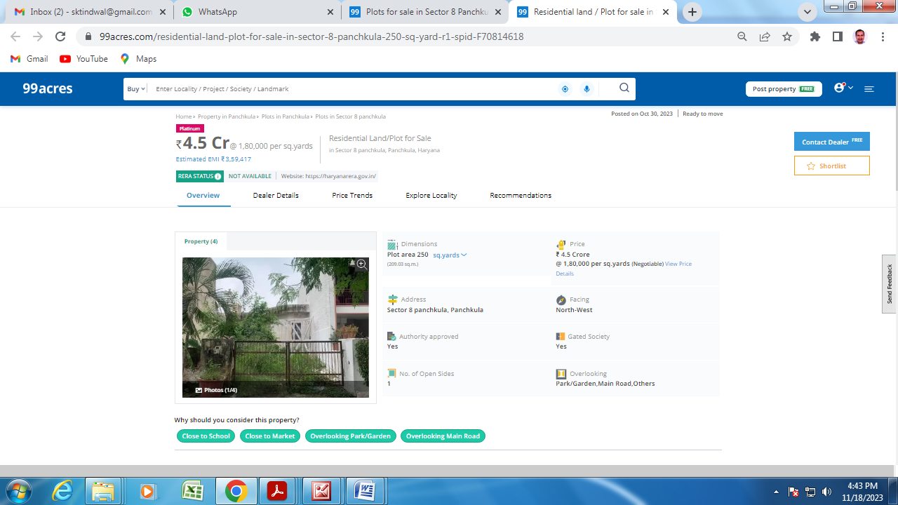

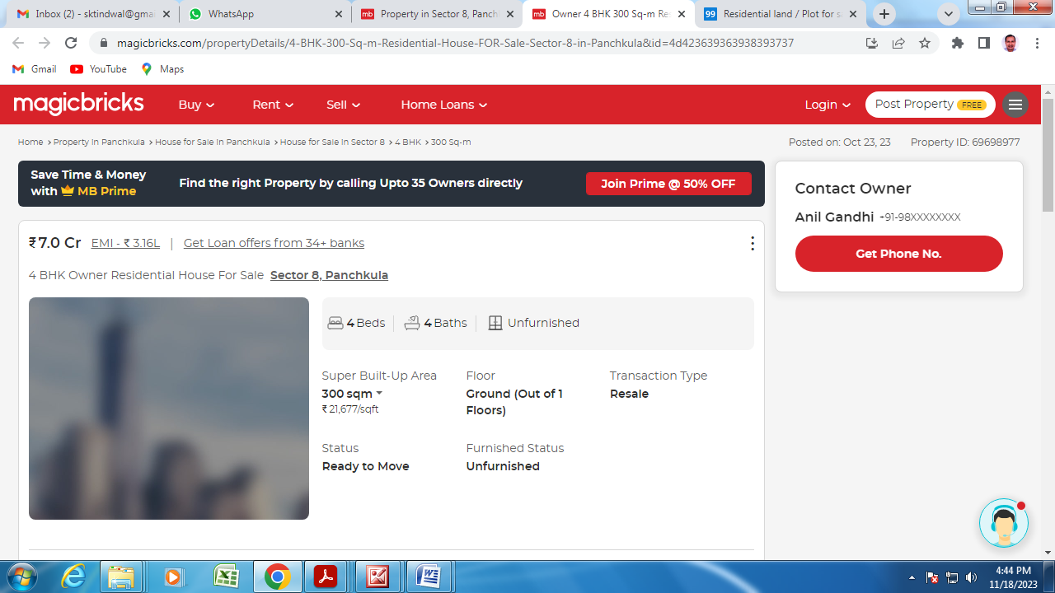

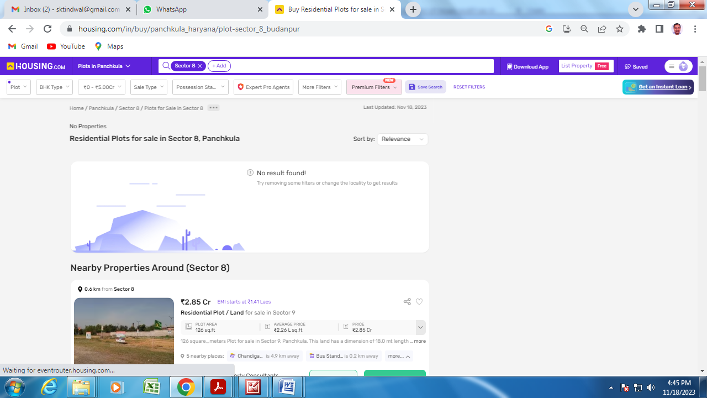

**Photos of H No. 651, Sec 8, Urban Estate, Panchkula, Hr. 134109**

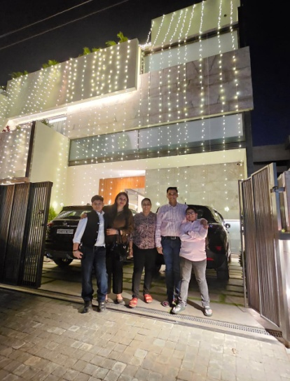 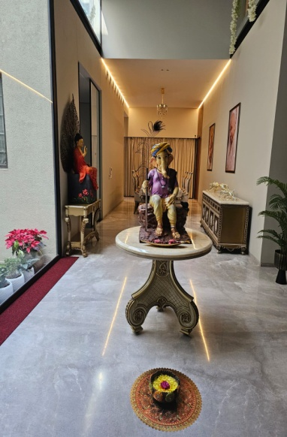 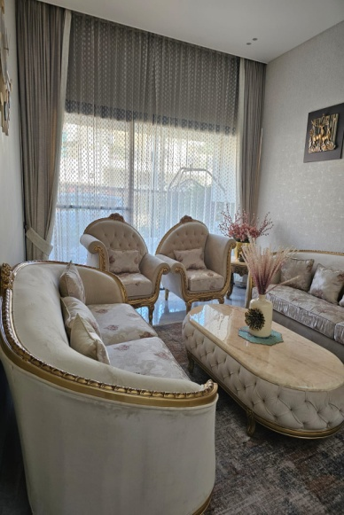

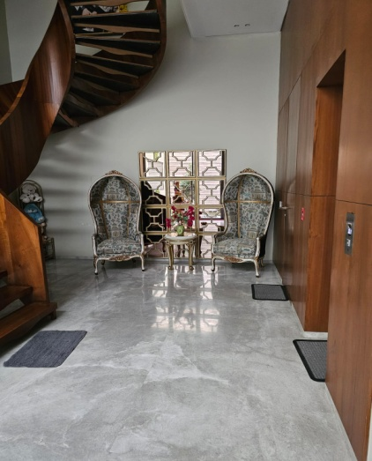 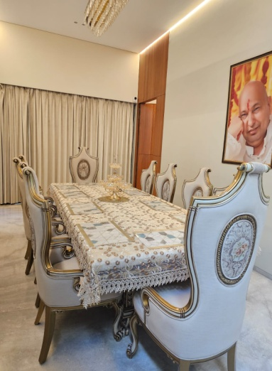 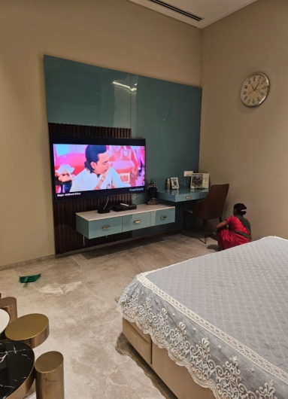

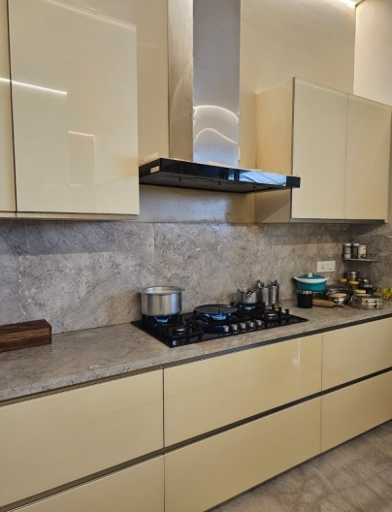 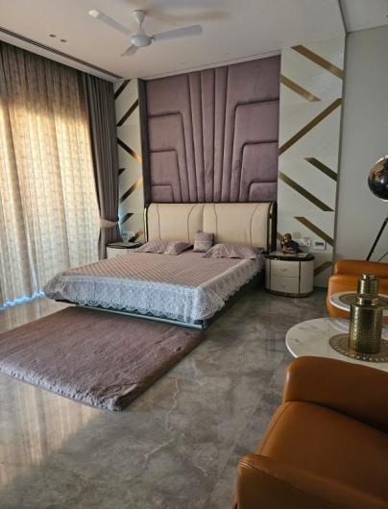 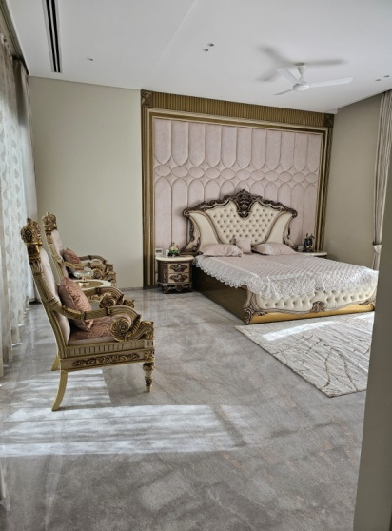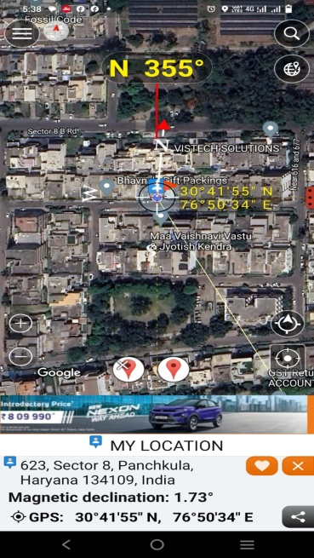

**Google Location**

**Signature of Valuer**

**Annexure-I**

**Format of undertaking to submitted by Individuals/proprietor/partners/direction DECLARATION-CUM-UNDERTAKING**

I,Surinder Kumar Tindwal son of Late Sh. Chhelu Ram do hereby solemnly affirm and state that: a. I am a citizen of India b. I will not undertake valuation of any assets in which I have a direct or indirect interest or become so interested at any time during a period of three years prior to my appointment as valuer or three years after the valuation of assets was conducted by me c. The information furnished in my valuation report dated DD-MM-YYYY is true and correct to the best of my knowledge and belief and I have made an impartial and true valuation of the property. d. I have personally inspected the property on DD-MM-YYYY The work is not subcontracted to any other valuer and carried out by myself. e. Valuation report is submitted in the format as prescribed by the Bank f. I have not been depanelled/ delisted by any other bank and in case any such depanelment by other banks during my empanelment with you, I will inform you within 3 days of such depanelment. f. I have not been removed/dismissed from service/employment earlier g. I have not been convicted of any offence and sentenced to a term of imprisonment h. I have not been found guilty of misconduct in professional capacity L have not been declared to be unsound mind J. I am not an undischarged bankrupt, or has not applied to be adjudicated as a bankrupt; k. I am not an undischarged insolvent L. I have not been levied a penalty under section 2711 of Income-tax Act, 1961 (43 of 1961) and time limit for filing appeal before Commissioner of Income tax (Appeals) or income-tax Appellate Tribunal, as the case may be has expired, or such penalty has been confirmed by Income-tax Appellate Tribunal, and five years have not elapsed after levy of such penalty m. I have not been convicted of an offence connected with any proceeding under the Income Tax Act 1961, Wealth Tax Act 1957 or Gift Tax Act 1958 and n. My PAN Card number/Service Tax number as applicable is o. I undertake to keep you informed of any events or happenings which would make me ineligible for empanelment as a valuer

I have not concealed or suppressed any material information, facts and records and I have made a complete and full disclosure q. Thave read the Handbook on Policy, Standards and procedure for Real Estate Valuation, 2011 of the IBA and this report is in conformity to the "Standards" enshrined for valuation in the Part-B of the above handbook to the best of my ability r. I have read the International Valuation Standards (IVS) and the report submitted to the Bank for the respective asset class is in conformity to the "Standards" as enshrined for valuation in the IVS in "General Standards" and "Asset Standards" as applicable s. I abide by the Model Code of Conduct for empanelment of valuer in the Bank (Annexure V-A signed copy of same to be taken and kept along with this declaration) t. I am registered under Section 34 AB of the Wealth Tax Act, 1957. (Strike off, if not applicable) u. I am valuer registered with Insolvency & Bankruptcy Board of India (IBBI) (Strike off, if not applicable) v. My CIBIL Score and credit worthiness is as per Bank's guidelines, w. I am the proprietor/partner/authorized official of the firm/company, who is competent to sign this valuation report. x. I will undertake the valuation work on receipt of Letter of Engagement generated from the system (i.e. LLMS/LOS) only. y. Further, I hereby provide the following information.

|  |  |  |
| --- | --- | --- |
| **Sl No.** | **Particulars** | **Valuer comment** |
| 1 | background information of the asset being valued; | **H No. 651, Sec 8, Urban Estate, Panchkula, Hr. 134109** |
| 2 | purpose of valuation and appointing authority | Bank’s purpose |
| 3 | identity of the valuer and any other experts involved in the valuation; | Surinder Kumar Tindwal |
| 4 | disclosure of valuer interest or conflict, if any; | NO |
| 5 | date of appointment, valuation date and date of report: | 17.11.2023, 17.11.2023, 17.11.2023 |
| 6 | inspections and/or investigations undertaken; | Inspection on 17.11.2023and meeting/ discussion/inquiry with property consultants of the area |
| 7 | nature and sources of the information used or relied upon; | Real estate web portals and property consultants of the area |
| 8 | procedures adopted in carrying out the valuation and valuation standards followed; | Market approach adopted being the property non income fetching and marketable |
| 9 | restrictions on use of the report, if any; | For exclusive use of UCO Bank, Sector-8, Panchkulaand no other else. |
| 10 | major factors that were taken into account during the valuation; | Location, size, direction, frontage along road, specifications used in building and workmanship |
| 11 | major factors that were not taken into account during the valuation; | NA |
| 12 | Caveats, limitations and disclaimers to the extent they explain or elucidate the limitations faced by valuer, which shall not be for the purpose of limiting his responsibility for the valuation report. | **i**. I/We have not verified the title deeds of the properties with the records of registrar’s office as this is beyond the agreed scope of our services stated in our engagement letter.  ii. I/We assume no responsibility for the legal matters including, but not limited to, legal or title concerns. The assets and interests therein have been valued free and clear of any liens or encumbrances unless stated otherwise. No hidden or apparent conditions regarding the subject assets or their ownership are assumed to exist. No opinion of title is rendered by this report and a good title is assumed.  iii. The RV has end eavoured to visually identify the land boundaries and dimensions; however, he is not a surveyor. So where there is a doubt about the precise position of the structures, it is recommended that a Licensed Surveyor be contacted.  iv. The physical condition of the improvements was based on visual inspection. No liability is assumed for the soundness of the structure since no engineering tests were made at the site. Any unknown conditions existing at the time of inspection could alter the value. No responsibility is assumed for latent defects of any nature whatsoever, which may affect value, nor for any expertise required to disclose such conditions.  v. Where a sketched plan is attached to this report, it does not purport to represent accurate architectural plans. Sketch plans and photographs are provided as general illustrations only.  vi. Unless otherwise stated as part of the terms of engagement, the RV has not made a specific compliance survey or analysis of the various permits and licenses under central, state and local laws / regulations applicable to the operation and use of the subject property, and this valuation does not consider the effect, if any, of non-compliance.  vii. The sale of the subject property is assumed to be on an all cash basis. Financial arrangements would affect the price at which the property may sell for if placed on the market.  viii. Value varies with the purpose and date. This report is not to be referred if the purpose is different other than mentioned.  ix. The actual realizable value that is likely to be fetched upon sale of the property under consideration shall entirely depend on the demand and supply of the same in the market at the time of sale.  x. In the course of the valuation, we were provided with both written and verbal information. We have however, evaluated the information provided to us by the Company through broad inquiry, analysis and review but have not carried out a due diligence or audit of the information provided for the purpose of this engagement. Our conclusions are based on the assumptions, forecasts and other information given by/on behalf of the Company.  xi. We are independent of the client/company and have no current or expected interest in the Company or its assets. The fee paid for our services in no way influenced the results of our analysis.  xii. Our report is meant for the purpose mentioned above and should not be used for any purpose other than the purpose mentioned therein. The Report should not be copied or  reproduced without obtaining our prior written approval for any purpose other than the purpose for which it is prepared. |

**Date: 17.11.2023**

**Place: Panchkula**

**Signature**

**(Name of the approved valuer and seal of the Firm/company)**

**(Annexure-II)**

**MODEL CODE OF CONDUCT FOR VALUERS**

**Integrity and Fairness**

**1.** A valuer shall, in the conduct of his/its business, follow high standards of integrity and fairness in all his/its dealings with his/its clients and other valuers.

2.A valuer shall maintain integrity by being honest, straightforward, and forthright in all professional relationships.

3.A valuer shall endeavour to ensure that he/it provides true and adequate information and shall not misrepresent any facts or situations.

4.A valuer shall refrain from being involved in any action that would bring disrepute to the profession.

5.A valuer shall keep public interest foremost while delivering his services.

Professional Competence and Due Care

6.A valuer shall render at all times high standards of service, exercise due diligence, ensure proper care and exercise independent professional judgment.

7.A valuer shall carry out professional services in accordance with the relevant technical and professional standards that may be specified from time to time

8.A valuer shall continuously maintain professional knowledge and skill to provide competent professional service based on up-to-date developments in practice, prevailing regulations/guidelines and techniques.

9.In the preparation of a valuation report, the valuer shall not disclaim liability for his/its expertise or deny his/its duty of care, except to the extent that the assumptions are based on statements of fact provided by the company or its auditors or consultants or information available in public domain and not generated by the valuer.

10.A valuer shall not carry out any instruction of the client insofar as they are incompatible with the requirements of integrity, objectivity and independence.

11.A valuer shall clearly state to his client the services that he would be competent to provide and the services for which he would be relying on other valuers or professionals or for which the client can have a separate arrangement with other valuers.

Independence and Disclosure of Interest

12.A valuer shall act with objectivity in his/its professional dealings by ensuring that his/its decisions are made without the presence of any bias, conflict of interest, coercion, or undue influence of any party, whether directly connected to the valuation assignment or not.

13.A valuer shall not take up an assignment if he/it or any of his/its relatives or associates is not independent in terms of association to the company.

14.A valuer shall maintain complete independence in his/its professional relationships and shall conduct the valuation independent of external influences.

15.A valuer shall wherever necessary disclose to the clients, possible sources of conflicts of duties and interests, while providing unbiased services.

16.A valuer shall not deal in securities of any subject company after any time when he/it first becomes aware of the possibility of his/its association with the valuation, and in accordance with the Securities and Exchange Board of India (Prohibition of Insider Trading) Regulations, 2015 or till the time the valuation report becomes public, whichever is earlier.

17.A valuer shall not indulge in “mandate snatching” or offering “convenience valuations” in order to cater to a company or client’s needs.

18.As an independent valuer, the valuer shall not charge success fee.

19.In any fairness opinion or independent expert opinion submitted by a valuer, if there has been a prior engagement in an unconnected transaction, the valuer shall declare the association with the company during the last five years.

**Confidentiality**

20.A valuer shall not use or divulge to other clients or any other party any confidential information about the subject company, which has come to his/its knowledge without proper and specific authority or unless there is a legal or professional right or duty to disclose.

Information Management

21.A valuer shall ensure that he/ it maintains written contemporaneous records for any decision taken, the reasons for taking the decision, and the information and evidence in support of such decision. This shall be maintained so as to sufficiently enable a reasonable person to take a view on the appropriateness of his/its decisions and actions.

22.A valuer shall appear, co-operate and be available for inspections and investigations carried out by the authority, any person authorised by the authority, the registered valuers organisation with which he/it is registered or any other statutory regulatory body.

23.A valuer shall provide all information and records as may be required by the authority, the Tribunal, Appellate Tribunal, the registered valuers organisation with which he/it is registered, or any other statutory regulatory body.

24.A valuer while respecting the confidentiality of information acquired during the course of performing professional services, shall maintain proper working papers for a period of three years or such longer period as required in its contract for a specific valuation, for production before a regulatory authority or for a peer review. In the event of a pending case before the Tribunal or Appellate Tribunal, the record shall be maintained till the disposal of the case.

**Gifts and hospitality.**

25.A valuer or his/its relative shall not accept gifts or hospitality which undermines or affects his independence as a valuer.

Explanation: For the purposes of this code the term ‘relative’ shall have the same meaning as defined in clause (77) of Section 2 of the Companies Act, 2013 (18 of 2013).

26.A valuer shall not offer gifts or hospitality or a financial or any other advantage to a public servant or any other person with a view to obtain or retain work for himself/ itself, or to obtain or retain an advantage in the conduct of profession for himself/ itself.

**Remuneration and Costs.**

27.A valuer shall provide services for remuneration which is charged in a transparent manner, is a reasonable reflection of the work necessarily and properly undertaken, and is not inconsistent with the applicable rules.

28.A valuer shall not accept any fees or charges other than those which are disclosed in a written contract with the person to whom he would be rendering service. Occupation, employability and restrictions.

29.A valuer shall refrain from accepting too many assignments, if he/it is unlikely to be able to devote adequate time to each of his/ its assignments.

30.A valuer shall not conduct business which in the opinion of the authority or the registered valuer organisation discredits the profession.

**Signature**

**(Name of the approved valuer and seal of the Firm/company)**